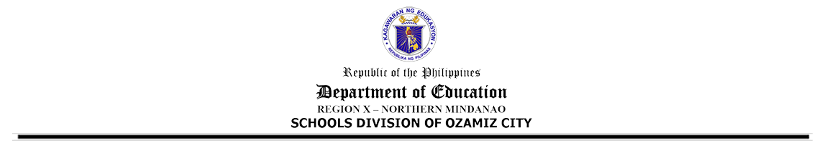
LOCATOR SLIP
Official Transaction Outside Perment Station

Powered by TCPDF (www.tcpdf.org)

